Docker CLI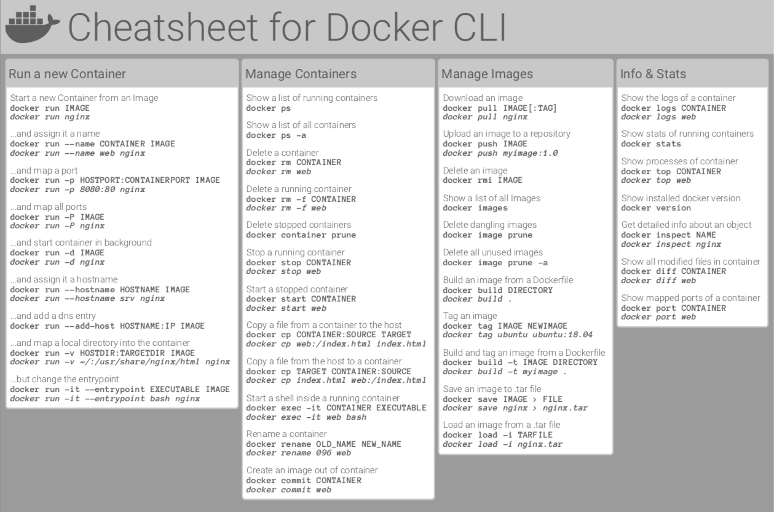



Container Management CLIs

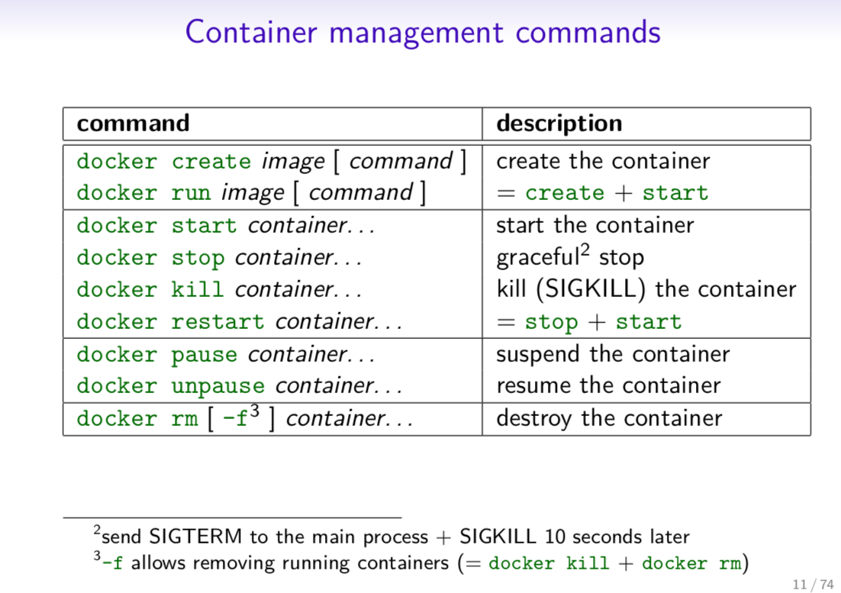

Inspecting The Container

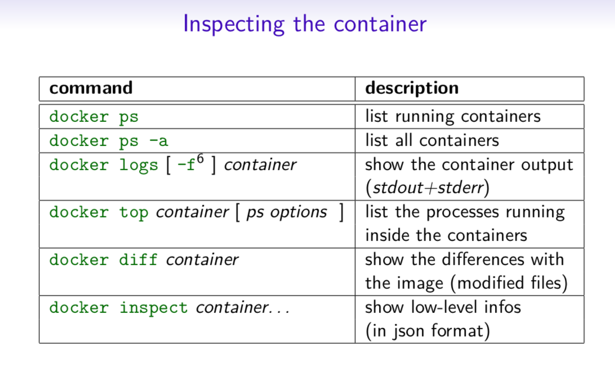

Interacting with Container

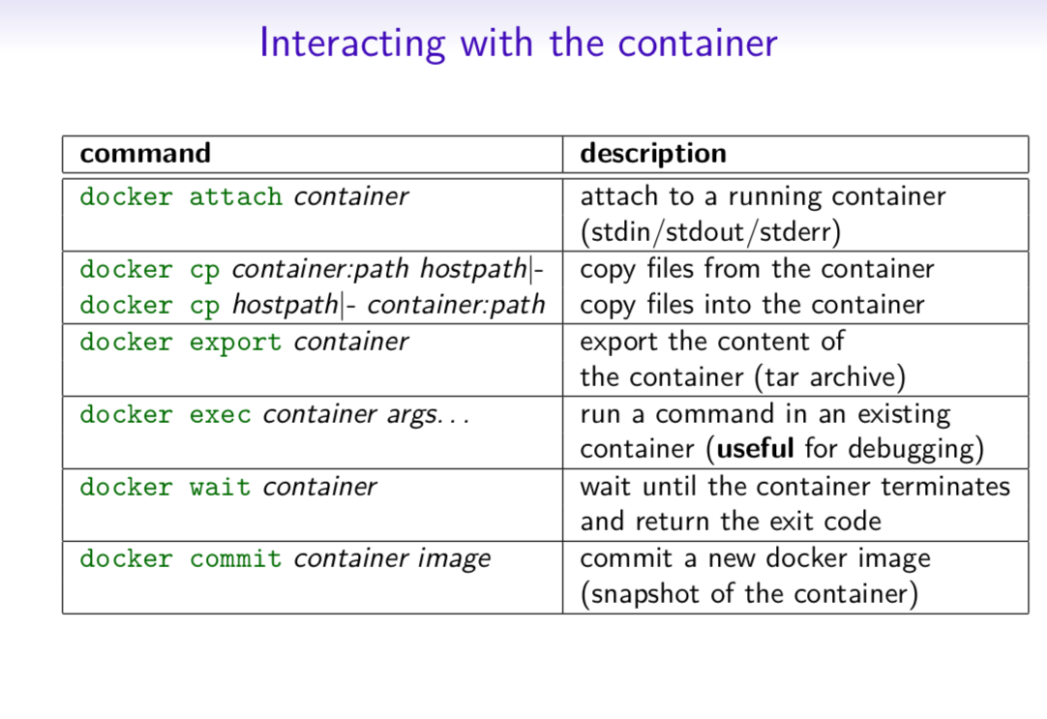

Image Management Commands

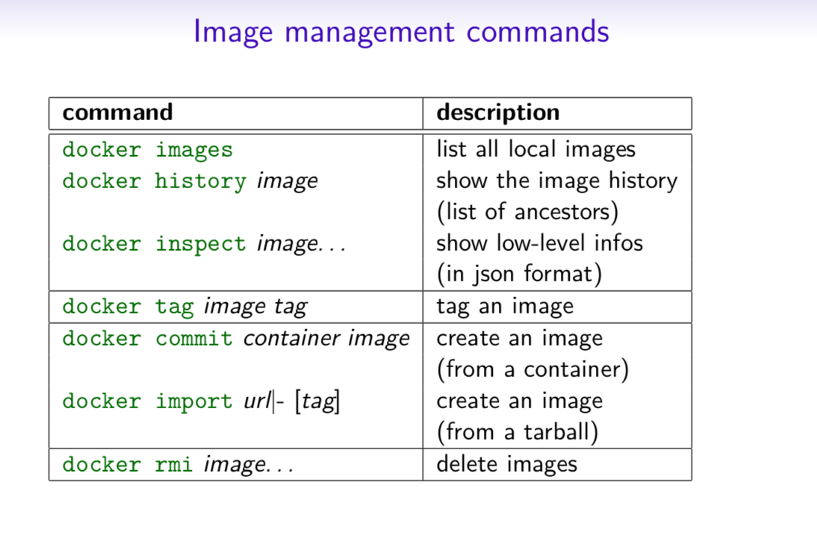

Image Transfer Commands

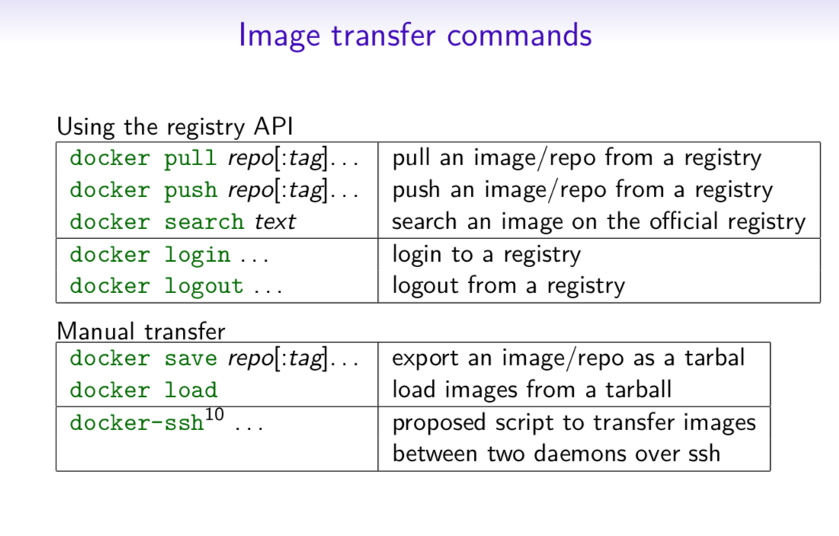

Builder Main Commands

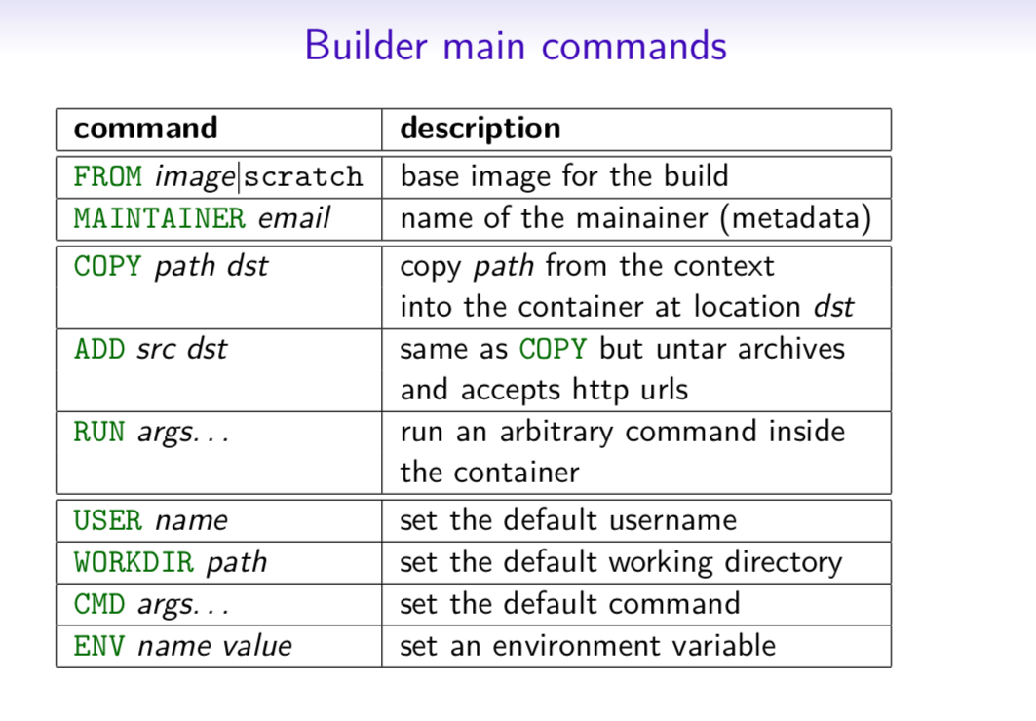

The Docker CLI

Manage images

docker build

docker build [options] .

-t "app/container_name" *# name*

Create an image from a Dockerfile.

docker run

docker run [options] IMAGE

# see `docker create` for options

Run a command in an image.

Manage containers

docker create

docker create [options] IMAGE

-a, --attach *# attach stdout/err*

-i, --interactive *# attach stdin (interactive)*

-t, --tty *# pseudo-tty*

--name NAME *# name your image*

-p, --publish 5000:5000 *# port map*

--expose 5432 *# expose a port to linked containers*

-P, --publish-all *# publish all ports*

--link container:alias *# linking*

-v, --volume `pwd`:/app *# mount (absolute paths needed)*

-e, --env NAME=hello *# env vars*

Example

$ docker create --name app_redis_1 \

--expose 6379 \

redis:3.0.2

Create a container from an image.

docker exec

docker exec [options] CONTAINER COMMAND

-d, --detach *# run in background*

-i, --interactive *# stdin*

-t, --tty *# interactive*

Example

$ docker exec app_web_1 tail logs/development.log

$ docker exec -t -i app_web_1 rails c

Run commands in a container.

docker start

docker start [options] CONTAINER

-a, --attach *# attach stdout/err*

-i, --interactive *# attach stdin*

docker stop [options] CONTAINER

Start/stop a container.

docker ps

$ docker ps

$ docker ps -a

$ docker kill $ID

Manage containers using ps/kill.

Images

docker images

$ docker images

REPOSITORY TAG ID

ubuntu 12.10 b750fe78269d

me/myapp latest 7b2431a8d968

$ docker images -a *# also show intermediate*

Manages images.

docker rmi

docker rmi b750fe78269d

Deletes images.

Also see

* [Getting Started](http://www.docker.io/gettingstarted/) *(docker.io)*

Dockerfile

Inheritance

**FROM** ruby:2.2.2

Variables

**ENV** APP_HOME /myapp

**RUN** mkdir $APP_HOME

Initialization

**RUN** bundle install

**WORKDIR** /myapp

**VOLUME** ["/data"]

*# Specification for mount point*

**ADD** file.xyz /file.xyz

**COPY** --chown=user:group host_file.xyz /path/container_file.xyz

Onbuild

**ONBUILD RUN** bundle install

*# when used with another file*

Commands

**EXPOSE** 5900

**CMD** ["bundle", "exec", "rails", "server"]

Entrypoint

**ENTRYPOINT** ["executable", "param1", "param2"]

**ENTRYPOINT** command param1 param2

Configures a container that will run as an executable.

**ENTRYPOINT** exec top -b

This will use shell processing to substitute shell variables, and will ignore any CMD or docker run command line arguments.

Metadata

**LABEL** version="1.0"

**LABEL** "com.example.vendor"="ACME Incorporated"

**LABEL** com.example.label-with-value="foo"

**LABEL** description="This text illustrates \

that label-values can span multiple lines."

See also

* <https://docs.docker.com/engine/reference/builder/>

docker-compose

Basic example

*# docker-compose.yml*

version: '2'

services:

web:

build: .

*# build from Dockerfile*

context: ./Path

dockerfile: Dockerfile

ports:

- "5000:5000"

volumes:

- .:/code

redis:

image: redis

Commands

docker-compose start

docker-compose stop

docker-compose pause

docker-compose unpause

docker-compose ps

docker-compose up

docker-compose down

Reference

Building

web:

*# build from Dockerfile*

build: .

*# build from custom Dockerfile*

build:

context: ./dir

dockerfile: Dockerfile.dev

*# build from image*

image: ubuntu

image: ubuntu:14.04

image: tutum/influxdb

image: example-registry:4000/postgresql

image: a4bc65fd

Ports

ports:

- "3000"

- "8000:80" *# guest:host*

*# expose ports to linked services (not to host)*

expose: ["3000"]

Commands

*# command to execute*

command: bundle exec thin -p 3000

command: [bundle, exec, thin, -p, 3000]

*# override the entrypoint*

entrypoint: /app/start.sh

entrypoint: [php, -d, vendor/bin/phpunit]

Environment variables

*# environment vars*

environment:

RACK_ENV: development

environment:

- RACK_ENV=development

*# environment vars from file*

env_file: .env

env_file: [.env, .development.env]

Dependencies

*# makes the `db` service available as the hostname `database`*

*# (implies depends_on)*

links:

- db:database

- redis

*# make sure `db` is alive before starting*

depends_on:

- db

Other options

*# make this service extend another*

extends:

file: common.yml *# optional*

service: webapp

volumes:

- /var/lib/mysql

- ./_data:/var/lib/mysql

Advanced features

Labels

services:

web:

labels:

com.example.description: "Accounting web app"

DNS servers

services:

web:

dns: 8.8.8.8

dns:

- 8.8.8.8

- 8.8.4.4

Devices

services:

web:

devices:

- "/dev/ttyUSB0:/dev/ttyUSB0"

External links

services:

web:

external_links:

- redis_1

- project_db_1:mysql

Hosts

services:

web:

extra_hosts:

- "somehost:192.168.1.100"

sevices

To view list of all the services runnning in swarm

docker service ls

To see all running services

docker stack services stack_name

to see all services logs

docker service logs stack_name service_name

To scale services quickly across qualified node

docker service scale stack_name_service_name=replicas

clean up

To clean or prune unused (dangling) images

docker image prune

To remove all images which are not in use containers , add - a

docker image prune -a

To prune your entire system

docker system prune

To leave swarm

docker swarm leave

To remove swarm ( deletes all volume data and database info)

docker stack rm stack_name

To kill all running containers

docker kill $(docekr ps -q )

